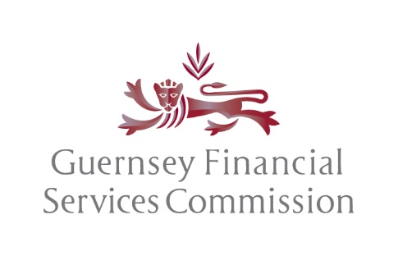

The AIFMD (Marketing) Rules and Guidance, 2021

notification in respect of an authorised, registered or non-guernsey collective investment scheme

full name and address of the alternative investment fund manager:

full name and address of the alternative investment fund:

self-managed alternative investment fund: (yes/no)

crm scheme reference number (if already an existing authorised/registered scheme):

european economic area jurisdiction(s) in which marketing is to be conducted in: | marketed to retail and/or professional investors:
 | retail (yes/no) | professional (yes/no)

name of the competent authority(ies) in the relevant european economic area jurisdiction(s):

manner of marketing to be conducted:

commencement date(s) of marketing in each european economic jurisdiction(s):

DECLARATION BY THE ALTERNATIVE INVESTMENT FUND MANAGER OR ALTERNATIVE INVESTMENT FUND

I certify on behalf of the governing body, of the Alternative Investment Fund Manager or the Alternative Investment Fund, that we are permitted to market the scheme in the manner(s) stated above in the European Economic Area jurisdiction(s) concerned.

Signed on behalf of the Alternative Investment Fund Manager or Alternative Investment Fund.

Signed |  | Date
Name and position
(See Note 1)
Institution

Address

Telephone number

The Data Protection (Bailiwick of Guernsey) Law, 2017
For the purpose of the Data Protection (Bailiwick of Guernsey) Law, 2017 please note that any personal data provided to the Commission will be used by the Commission to discharge its regulatory activities and statutory functions. Further information, relating to the Commission’s Data Protection policy, can be located on the website at www.gfsc.gg/data-protection

Note 1: This application form must be signed by two of the directors of the Applicant or in relation to an
unincorporated body, any member of the committee or similar governing body.

